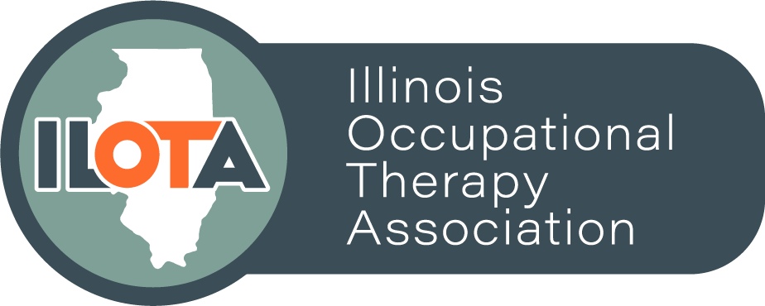

ILOTA STUDENT COMMITTEE 2021 - 2022 APPLICATION

Position Description – ILOTA Student Co-Liaison: The ILOTA Student Co-Liaisons act as the intermediary between ILOTA Student Committee and the ILOTA Board. ILOTA values student input, so this position allows the OT and OTA students to have a voice on the governing board of the association. The Student Co-Liaisons are tasked with promoting student involvement in ILOTA, planning student events (such as the Student Conclave and ILOTA Conference Student Event), attending quarterly ILOTA Board Meetings, leading quarterly Student Committee meetings as necessary, communicating with students and board members, and assisting the board with other tasks as deemed necessary. As a relatively new position, responsibilities of the Student Co-Liaison are continuing to evolve. For the 2021-2022 year, the goal is to have two ILOTA Student Co-Liaisons: one OT student and one OTA student. The new Student Co-Liaisons will take over in April 2021 with a transition period from May 2021 through June 2021. The Student Co-Liaisons will hold this position until April 2022 after the 2022 ILOTA Student Conclave.

Position Description – ILOTA Student Committee Member: The goal is to have one student representative from each Illinois OT and OTA school on this committee. Members of the committee gather feedback from their peers at their respective schools, and report back to the ILOTA Student Co-Liaisons. They also participate in quarterly in-person or virtual meetings with the ILOTA Student Co-Liaisons to assist in planning student events. Finally, Student Committee Members assist with promoting student involvement in ILOTA, especially student events. Members will join the committee in April 2021 until April 2022.

Candidate Requirements: Applicants for both the Student Co-Liaison and Student Committee Member positions must be an ILOTA member in good standing and a current OT or OTA student in good academic standing at their school. Applicants should be passionate about ILOTA, demonstrate good organization and communication skills, and be creative and innovative in their ideas.

Instructions: Students may apply for either position or both. Students applying for both positions will first be considered for the Co-Liaison position and if they are not selected for that position, they will then be considered for the Committee Member position. Fill out the application below and submit it to the ILOTA Networking Coordinator, Brian Herr, at brian.herr6@gmail.com by March 26th, 2021 at 8pm. No late applications will be accepted. Candidates will be notified of decision via email by April 2nd, 2021. If you have any questions about the position, please contact Brian Herr at brian.herr6@gmail.com

ILOTA STUDENT COMITTEE 2021 - 2022 APPLICATION
Name:
Email:
School:
Anticipated Date of Graduation:
ILOTA Member Number:
Position(s) for which you are applying: __Co-Liaison __Student Committee Member __Both

Please attach a professional resume/CV with application and answer the following questions:

Why are you interested in being in the position for which you are applying? (limit to 300 words)

How do you plan to get more students involved with ILOTA? How can ILOTA better serve students? (limit to 300 words)

