ILOTA Conversations That Matter in Community-Based Practice - 10/4/21 at 7pm CT

Mentimeter Activity Responses
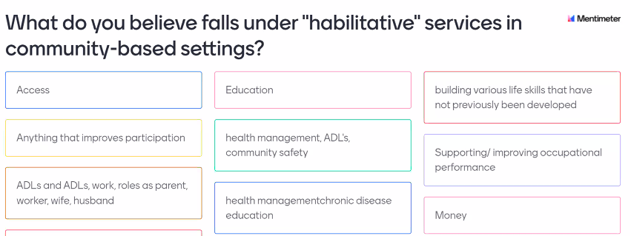
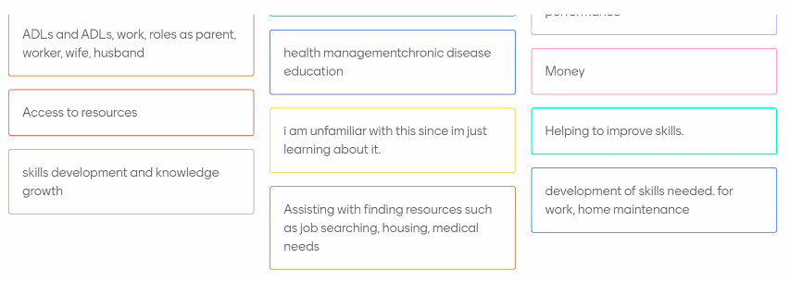

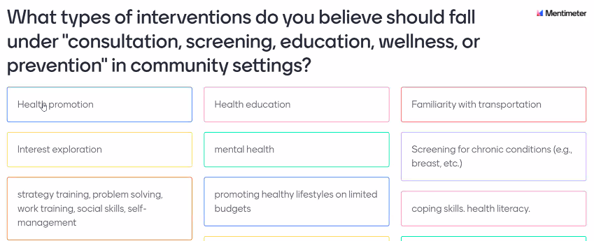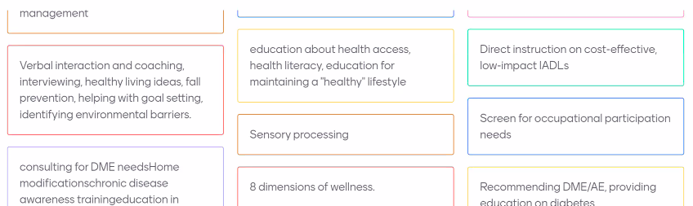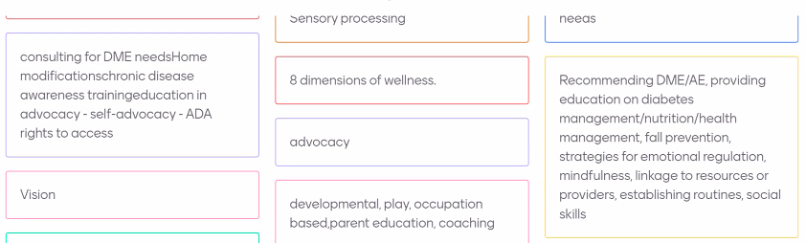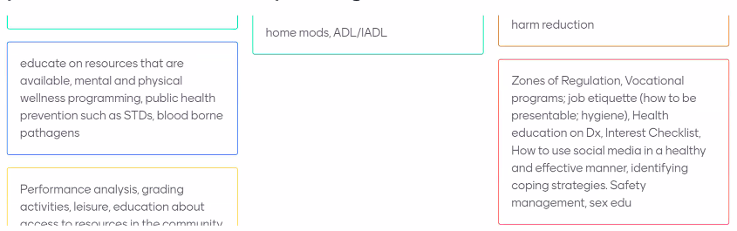
To provide some context for this conversation, the current IL OT Practice Act, Section 3.1b, states:
- ‘A referral is not required for the purpose of providing consultation, habilitation, screening, education, wellness, prevention, environmental assessments, and work-related ergonomic services to individuals, groups, or populations.’

Section 3.1 of the Act also states:
- ‘Except as indicated in subsections (b) and (c) of this Section, implementation of direct occupational therapy treatment to individuals for their specific health care conditions shall be based upon a referral from a licensed physician, dentist, podiatric physician, advanced practice registered nurse, physician assistant, or optometrist.’

Recent conversation with the licensure board’s legal counsel clarified their interpretations of the law as follows:
- “as the act is currently written, licensed OTs would need a referral for any intervention/treatment (e.g. providing exercises or adaptive equipment) even if their official role was not that of an OT.”

The purpose of today’s conversation is to explore the following:

How do we define the services we provide to individuals, groups, or populations:
- Consultation:

- Habilitation:
  - Client #2 thoughts:
    - Two OT practitioners expressed that they thought services fit under this category. They also said they felt more comfortable providing these services as part of a interdisciplinary team

- Screening:

- Education:
  - Client #1 thoughts:
    - One practitioner shared that they thought services focused on education in that the client was continuing to be an active participant in their ADLs/IADLs.
    - One practitioner noted: “I think it also becomes really sticky when you are discussing ‘healthy aging’ interventions versus ‘healthy aging with a disability/disease” … healthy aging is really such a new area”
  - Client #2 thoughts:
    - One practitioner shared that they thought services focused on health literacy in that they provided more opportunities for the client to understand their health condition

- Wellness:

- Prevention:
  - Levels of Prevention; possible role of OT is acknowledging there is a disease but focusing on the prevention of worsening health conditions

- Environmental assessments:

- Work-related ergonomic services:

What are the unintended consequences of a more comprehensive scope for direct access to OT?
If medical intervention, how/when do we need a referral

Consider OT’s 7 Core Values: Altruism, Equality, Freedom, Justice, Dignity, Truth, Prudence*

Potential Benefits | Ethical Principles (AOTA, 2020) | Potential Risks or Harms
- Beneficence
OTP shall demonstrate a
concern for the well-being and safety of persons, taking action to incur benefit.
- Nonmaleficence
OTP shall refrain from actions
that cause harm.
 | - Autonomy  OTP shall respect the right of  the person to self- determination, privacy, confidentiality,  and consent. | Must find a way to address HIPAA regulations and confidentiality
More access to care (especially with the healthcare system increasing reliance on technology for obtaining medications and appointments; OTs are equipped to help clients navigate this) | - Justice  OTP shall promote equity,  inclusion, and objectivity in the provision of occupational  therapy services.
- Veracity
OTP shall provide
comprehensive, accurate, and objective information
when representing the profession.
- Fidelity
OTP shall treat clients
(persons, groups, or populations), colleagues, and other
professionals with respect, fairness, discretion,
and integrity.

Other Considerations:
- “OT’s should definitely have the opportunity to have direct access because we are more than a valid profession with the ability to decide services based on our clinical reasoning. We are capable!!”
- “I think this is really important food for thought and is helping me realize the possible need for direct access.”
- Sounds like if OT services are related to a dx, then we should be starting to think about the need for a referral
- Looks like community-based OT is operating on a more social model of health perspective vs medical model of health. Might be helpful to align ourselves with public health approach to care (e.g., population health)
- “I am an OTAS currently at a nontraditional bilingual community based setting in Chicago and I see some of my own clients in these cases. Something that is sticking with me is the challenges of client accessibility to their own medical management team and being educated on efficient ways to self advocate for wellness promotion; understanding our role as OTP's in these settings from a client and staff perspective to support our presence in these marginalized communities? Thanks for this platform, really excited to be part of this discussion!”
Based on today’s discussion, what revisions do we need to the IL OT Practice Act? What do we want our practice act to say?
- Include stipulations for direct access to OT in community based settings
  - What other professions have direct access (e.g., PT) and how did they get access? What barriers/supports existed for other professions to obtain direct access?
  - What other OT settings have direct access (e.g., school, ergonomics) and how did they do that?
  - Might be helpful to draw parallels between supervision required for OT students to provide care and MD “supervision” for OTs to provide care
- Focus our role on addressing health literacy; not the treatment of the condition so much as providing education and empowering someone in the health management role (e.g., education on navigating the healthcare system).
  - However, this might not address the concern of the high % of people leaving health care settings AMA and those who avoid the health care system
  - Thought: what is our ethical role for health equity and what would that look like? Is the goal to get them in a system that has historically not met their needs?

Other Resources:
- IL OT Practice Act: https://www.ilga.gov/legislation/ilcs/ilcs3.asp?ActID=1314&ChapterID=24
- AOTA OT Code of Ethics (2020): https://research.aota.org/ajot/article/74/Supplement_3/7413410005p1/6691/AOTA-2020-Occupational-Therapy-Code-of-Ethics
- AOTA Position Statement on OT Scope of Practice (2021): https://www.aota.org/-/media/Corporate/Files/Practice/Manage/official%20docs%20prepublication/ajot-75S3005-OT-Scope-of-Practice-aota.pdf
- OT Practice article defining Health Promotion Services in Congregate Housing Settings (2021): https://www.aota.org/Publications-News/otp/Archive/2021/congregate-housing.aspx
- OT Practice article on habilitative services (2015): https://www.aota.org/publications-news/otp/archive/2015/11-23-15/habilitative-services.aspx

*OT Core Value Definitions (AOTA, 2020):
- Altruism indicates demonstration of unselfish concern for the welfare of others. Occupational therapy personnel reflect this concept in actions and attitudes of commitment, caring, dedication, responsiveness, and understanding.
- Equality indicates that all persons have fundamental human rights and the right to the same opportunities. Occupational therapy personnel demonstrate this value by maintaining an attitude of fairness and impartiality and treating all persons in a way that is free of bias. Personnel should recognize their own biases and respect all persons, keeping in mind that others may have values, beliefs, or lifestyles that differ from their own. Equality applies to the professional arena as well as to recipients of occupational therapy services.
- Freedom indicates valuing each person’s right to exercise autonomy and demonstrate independence, initiative, and self-direction. A person’s occupations play a major role in their development of self-direction, initiative, interdependence, and ability to adapt and relate to the world. Occupational therapy personnel affirm the autonomy of each individual to pursue goals that have personal and social meaning. Occupational therapy personnel value the service recipient’s right and desire to guide interventions.
- Justice indicates that occupational therapy personnel provide occupational therapy services for all persons in need of these services and maintain a goal-directed and objective relationship with recipients of service. Justice places value on upholding moral and legal principles and on having knowledge of and respect for the legal rights of recipients of service. Occupational therapy personnel must understand and abide by local, state, and federal laws governing professional practice. Justice is the pursuit of a state in which diverse communities are inclusive and are organized and structured so that all members can function, flourish, and live a satisfactory life regardless of age, gender identity, sexual orientation, race, religion, origin, socioeconomic status, degree of ability, or any other status or attributes. Occupational therapy personnel, by virtue of the specific nature of the practice of occupational therapy, have a vested interest in social justice: addressing unjust inequities that limit opportunities for participation in society (Ashe, 2016; Braveman & Bass-Haugen, 2009). They also exhibit attitudes and actions consistent with occupational justice: full inclusion in everyday meaningful occupations for persons, groups, or populations (Scott et al., 2017).
- Dignity indicates the importance of valuing, promoting, and preserving the inherent worth and uniqueness of each person. This value includes respecting the person’s social and cultural heritage and life experiences. Exhibiting attitudes and actions of dignity requires occupational therapy personnel to act in ways consistent with cultural sensitivity, humility, and agility.
- Truth indicates that occupational therapy personnel in all situations should be faithful to facts and reality. Truthfulness, or veracity, is demonstrated by being accountable, honest, forthright, accurate, and authentic in attitudes and actions. Occupational therapy personnel have an obligation to be truthful with themselves, recipients of service, colleagues, and society. Truth includes maintaining and upgrading professional competence and being truthful in oral, written, and electronic communications.
- Prudence indicates the ability to govern and discipline oneself through the use of reason. To be prudent is to value judiciousness, discretion, vigilance, moderation, care, and circumspection in the management of one’s own affairs and to temper extremes, make judgments, and respond on the basis of intelligent reflection and rational thought. Prudence must be exercised in clinical and ethical reasoning, interactions with colleagues, and volunteer roles.

