Early Intervention Waitlist Data Exploratory Analysis:

As part of the Fiscal Health workgroup and Service Delays workgroup of IICEI, data on waiting lists was provided by the Bureau (a timeframe of 9/1/18 – 8/31/19) and analyzed to better understand extent of delays, and geographic and population disparities.

Issue 1: Certain children experience delays. | Page 2
Issue 2: Among cases that are delayed, certain children experience longer delays. | Pages 3-4
Issue 3: Certain areas of the state have more children waiting for services. | Pages 5-7
Issue 4: There are greater delays in certain services and there are racial differences in the reason for the delay. | Pages 8-11
Issue 5: | Pages 12-14
Issue 6: Children with lower incomes experience a greater likelihood of delays. | Pages 14-15
Recommendations | Page 15

Issue 1: Certain children experience delays.

Table 1.1: Delays and Non-Delays for Children Recommended for EI services

Race | Did not Experience a Delay | Did Experience a Delay | % Delayed | Ratio
Asian | 1295 | 131 | 9% | .10
Black | 5324 | 932 | 15% | .18
Hispanic | 10713 | 1266 | 11% | .11
Multiracial | 1114 | 174 | 14% | .16
Native American | 35 | 3 | 8% | .09
White | 21123 | 2071 | 9% | .1
Total | 39604 | 4577 | 10% | .12

Data was obtained for the time frame of 9/1/18 – 8/31/19; adding the total of children who did not experience a delay and those who did experience a delay equals the cumulative count of children who had an IFSP during this time period. Table 1.1 disaggregates children by race and whether or not they experience delays. Comparing across races, we see that 15% of black children experienced a delay compared to 9% of white and Asian children. Further exploration into these disparities occurs throughout this document. A chi squared test of independence showed that there was a significant association between race and delays, X² (5, n = 44181) = 206.54, p <.001.

Calculation Notes:
It is important to note that these are counts of the number of children that were delayed, not the number of services that were delayed. In order to avoid double counting, children that were referred and experienced delays for multiple services concurrently were only counted once- regardless of whether or not the delays were resolved at the same time. Alternatively, children who experienced multiple rounds of delays – meaning that they experience a delay that was resolved and then a new service was called for and delayed – were counted twice. In total, only 210 children met this criteria. Unless otherwise stated, this is the method for counting that will be used for all future questions.

Percent delayed is defined as the children who experience a delay divided by the total number of children:

$$\frac{Experienced a Delay}{\left(Did Not Experience a Delay\right)+(Did Experience a Delay)}$$

Issue 2: Among cases that are delayed, certain children experience longer delays.

Figure 2.1: Length of Unresolved Delays at 8/31/2019

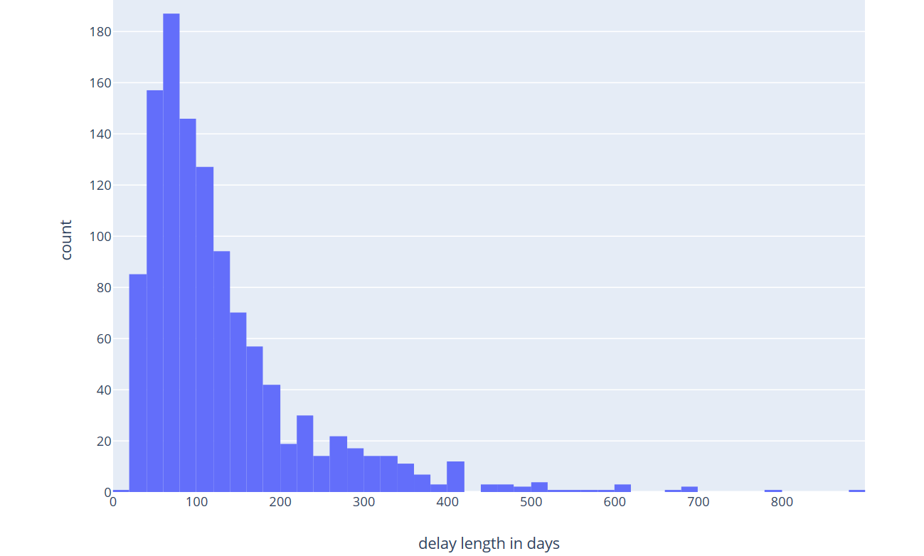

Figure 2.2: Length of Unresolved Delays for Black and White Children at 8/31/2019

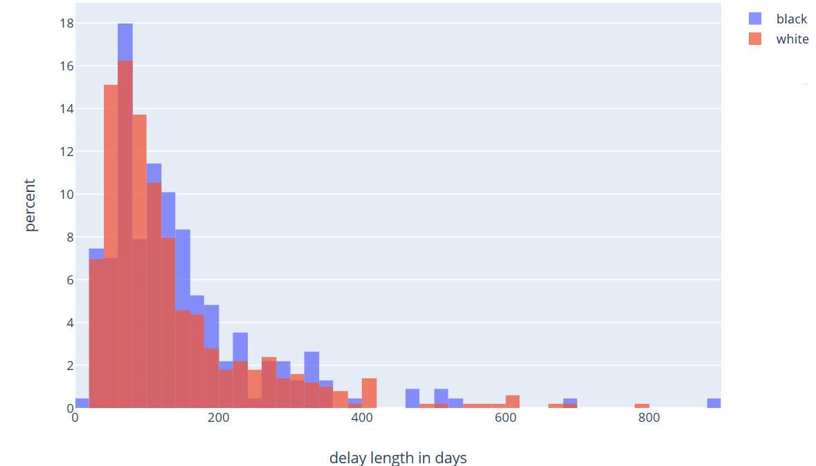

Table 2.1: Mean and Median Delay Length in Day for Unresolved Cases at 8/31/2019
 | Mean | Median
Black | 143 | 114
White | 133 | 94
Asian | 96 | 76
Hispanic | 119 | 96

1159 children and families were experiencing delays on 8/31/2019. Among these children and families, the average delay lasted an average of 130 days (a median of 100 days). 16 children had delays lasting longer than 500 days. It is important to note that delay length is calculated as the number of days between delay start date and 8/31/2019. Because the delay start date begins 30 days after the initial referral, families had been waiting their “delay length” plus 30 days. Figure 2.2 disaggregates figure 2.1 into the distributions for black and white children.

When comparing the lengths of unresolved delays at 8/31/2019 between black and white children, we see that black children experience longer delays than do white children. Table 2.1 expresses these difference numerically. It is noted that we see that Asian children in this time period experienced drastically shorter delays than do children from all other races.

Methodological Note: It is difficult to accurately calculate delay length because delays are automatically marked as resolved when a child turns 3. While it makes intuitive sense to calculate delay length as the difference between “delay start date” and “delay end date”, doing so would result in misleading figures and statistics. Because delays are automatically resolved when a child turns 3, there is an artificial “ceiling” on delay length, skewing the summary statistics. Consider a child whose delay starts at age 2 years and 11 months: their delay would automatically get resolved in 1 month, pulling down the average delay length and creating a downward bias in all statistics.

In order to work around this constraint, the analysis here concerns the length of unresolved delays as of 8/31/2019. While these figures give insight into the experiences of children and families who were experiencing delays on 8/31/2019, it would probably be incorrect to assume that these figures are representative of all delays. If one were to generalize this data to all delays, they would have to account for the downward bias created by the aforementioned age 3 cutoff. Similarly, an upward bias results from the fact that rapidly resolved delays are less likely to be included in this sample. Thus, it is best to understand these graphs and figures as offering insight into the experiences of families experiencing delays on 8/31/2019 and not overgeneralize the results.

In terms of cleaning the data, some entries of data was excluded from this analysis due to presumed data entry error. These cases included instances where a child’s delay start date predated their birthdays or their initial referral date. Additionally, delays that lasted over 900 days were excluded.

Issue 3: Certain areas of the state have more children waiting for services.

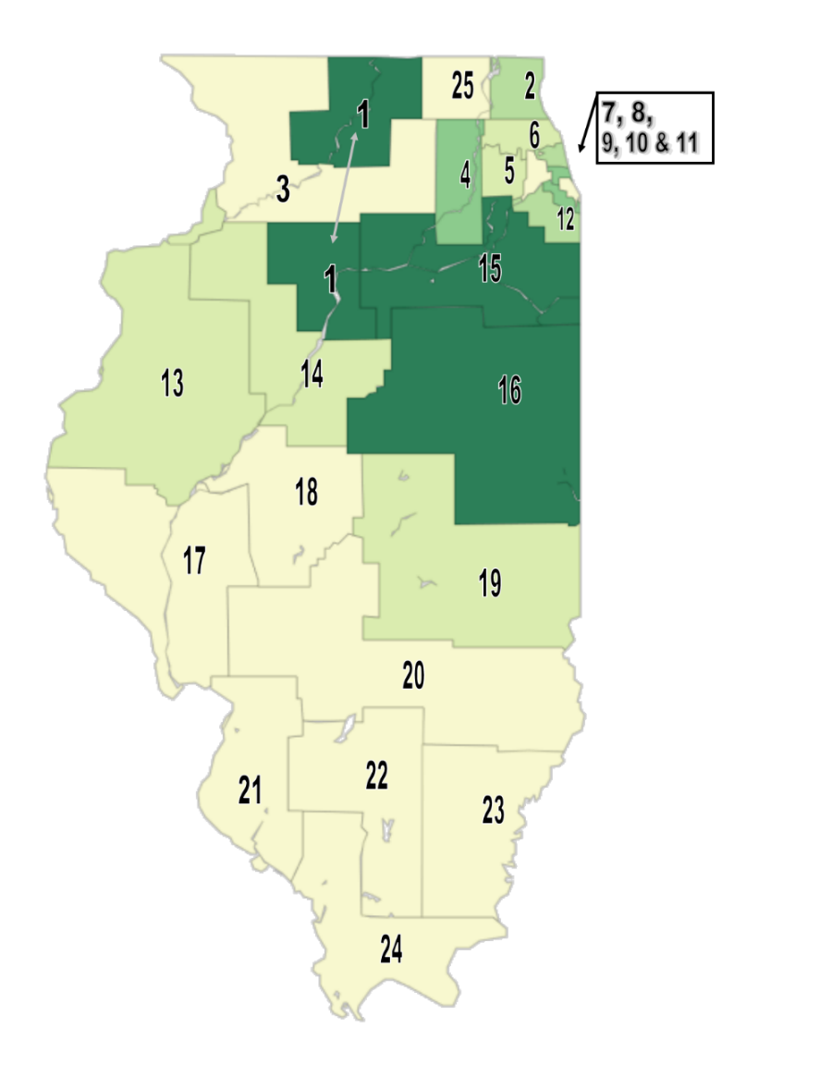
Fig 3.1: Number of Unresolved Delays at 8/31/2019 Per CFC
CFC | Unresolved Delays
1 | 147
2 | 58
3 | 18
4 | 75
5 | 26
6 | 37
7 | 3
8 | 90
9 | 78
10 | 24
11 | 74
12 | 61
13 | 30
14 | 50
15 | 150
16 | 134
17 | 6
18 | 5
19 | 32
20 | 7
21 | 1
22 | 1
23 | 13
24 | 12
25 | 21

Fig 3.2: Percent of Children that Experience Delays by CFC
CFC | N | Y | % delayed
1 | 989 | 522 | 35%
2 | 1397 | 174 | 11%
3 | 753 | 55 | 7%
4 | 1776 | 456 | 20%
5 | 2654 | 115 | 4%
6 | 3742 | 120 | 3%
7 | 2461 | 27 | 1%
8 | 1887 | 429 | 19%
9 | 2000 | 283 | 12%
10 | 1769 | 136 | 7%
11 | 4497 | 396 | 8%
12 | 2776 | 197 | 7%
13 | 431 | 109 | 20%
14 | 1253 | 246 | 16%
15 | 3074 | 529 | 15%
16 | 1179 | 381 | 24%
17 | 468 | 9 | 2%
18 | 772 | 28 | 4%
19 | 994 | 89 | 8%
20 | 995 | 73 | 7%
21 | 1356 | 5 | 1%
22 | 788 | 12 | 2%
23 | 324 | 37 | 10%
24 | 355 | 36 | 9%
25 | 915 | 113 | 11%
total | 39605 | 4577 | 10%
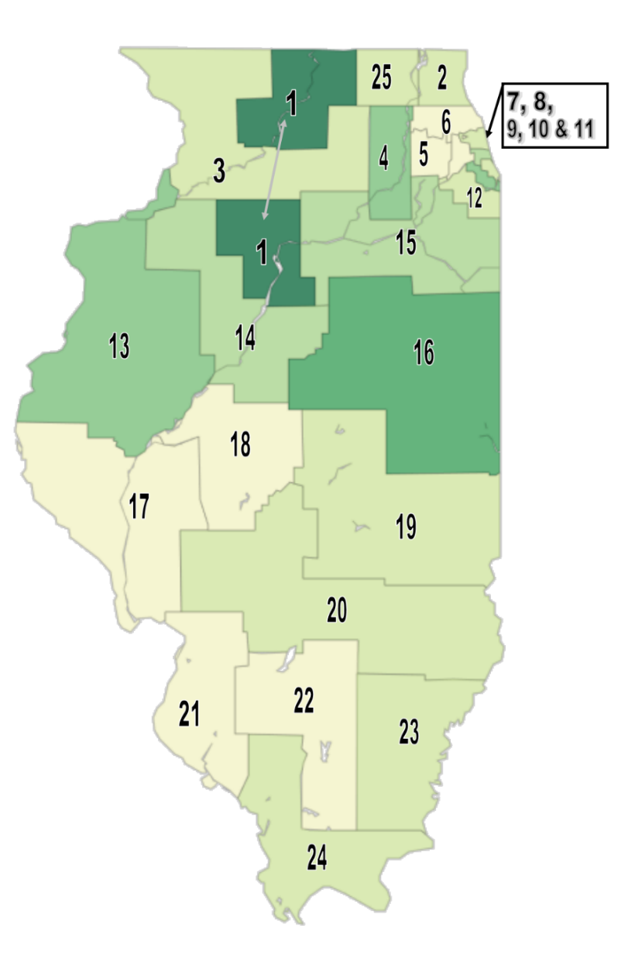

Fig 3.2: Percent of Children that Experience Delays by CFC, bar chart

The map in fig 3.1 shows a geographic disparity in the number of unresolved cases. Across CFCs, the number of unresolved cases on 8/31/2019 ranges from 1 in CFCs 21 and 22 to 150 unresolved delays in CFC 15. A potential issue with this visualization is that mapping unresolved cases may overweight CFCs with large caseloads. In order to address this concern, figure 3.2 graphs the proportion of children that experienced a delay for each CFC. Percent Delayed is defined as the number of children that experienced a delay divided by the sum of children who did and did not experience delays.

Shifting from unresolved cases to the percent of children that experienced a delay changes the focus of map 3.2 and graphically, we can observe this same data in figure 3.3. The CFCs experiencing the highest percentage (20% or more) of unresolved cases are 1, 4, 13, and 16.

Issue 4: There are greater delays in certain services and there are racial differences in the type and reason for the delay.

Figure 4.1 Delay Reason by Service Codes
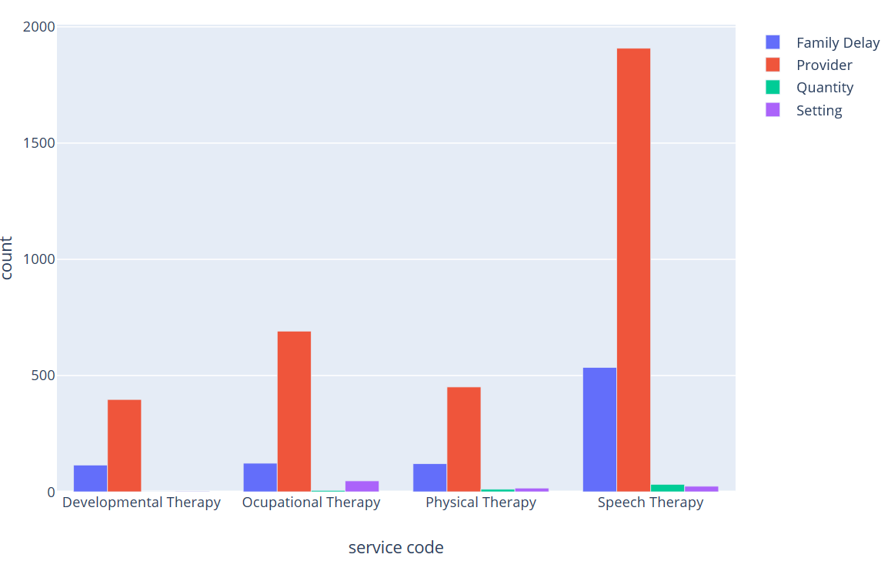

Table 4.1: Definition of Delay Codes

Family Delay | This should be used when the delay is due to the family. If the CFC located a provider to perform the consented IFSP service (matching any/all insurance qualifications as well) but the
Provider | This delay reason is to be used for a child who receives no services due to the inability to locate a provider to conduct one or more of the services listed on the IFSP. (This does not include the inability to find a provider due to family reasons). The child would be entered for each Service Code type that no service is received as consented to in the IFSP.
Quantity | Unable to find as much service as recommended – This delay reason is to be used for a child who is getting some of the recommended service but not all of the recommended service as listed on the IFSP. The child is listed once per service code type if they are not receiving the consented services for more than one type.
Setting | Service being provided in other than natural setting – this delay code should be used when the child is receiving services, but not in the natural environment.

Figure 4.2: Delayed Service Codes by Race
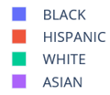  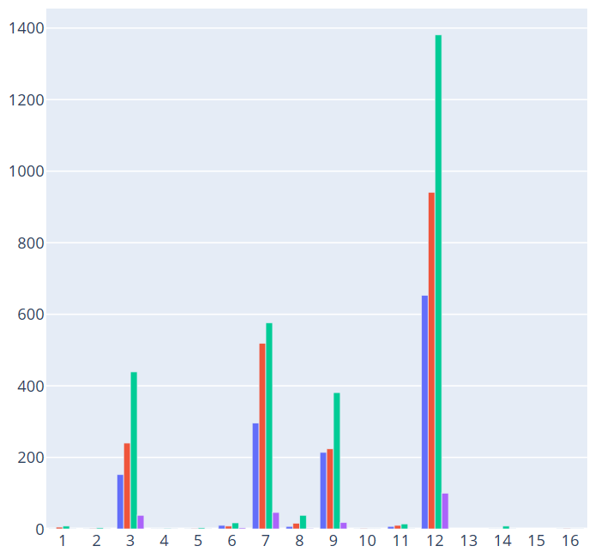 | Description  1 Audiological  2 Assistive Technology  3 Developmental Therapy  4 Medical (Diagnostic Eval)  5 Nursing/Health  6 Nutrition  7 Occupational Therapy  8 Psychological  9 Physical Therapy  10 Service Coordination  11 Social Work  12 Speech Therapy  13 Transportation  14 Vision  15 Health  16 Family Training/Support

Table 4.2: Delayed Service Codes by Race

 | 1 | 2 | 3 | 4 | 5 | 6 | 7 | 8 | 9 | 10 | 11 | 12 | 14 | 16
ASIAN | 0 | 0 | 11 | 0 | 0 | 2 | 25 | 1 | 9 | 0 | 0 | 83 | 0 | 0
BLACK | 0 | 0 | 88 | 0 | 0 | 5 | 168 | 4 | 150 | 0 | 4 | 513 | 0 | 0
HISP. | 3 | 1 | 125 | 0 | 1 | 3 | 271 | 7 | 147 | 1 | 9 | 697 | 0 | 1
MULTI | 0 | 0 | 24 | 0 | 0 | 0 | 46 | 0 | 15 | 0 | 0 | 89 | 0 | 0
WHITE | 5 | 1 | 267 | 1 | 1 | 8 | 357 | 22 | 278 | 0 | 11 | 1117 | 3 | 0
total | 8 | 2 | 515 | 1 | 2 | 18 | 867 | 34 | 599 | 1 | 24 | 2499 | 3 | 1

Figure 4.3: Physical, Developmental, Occupational, and Speech Therapy Delays by Race (subset)
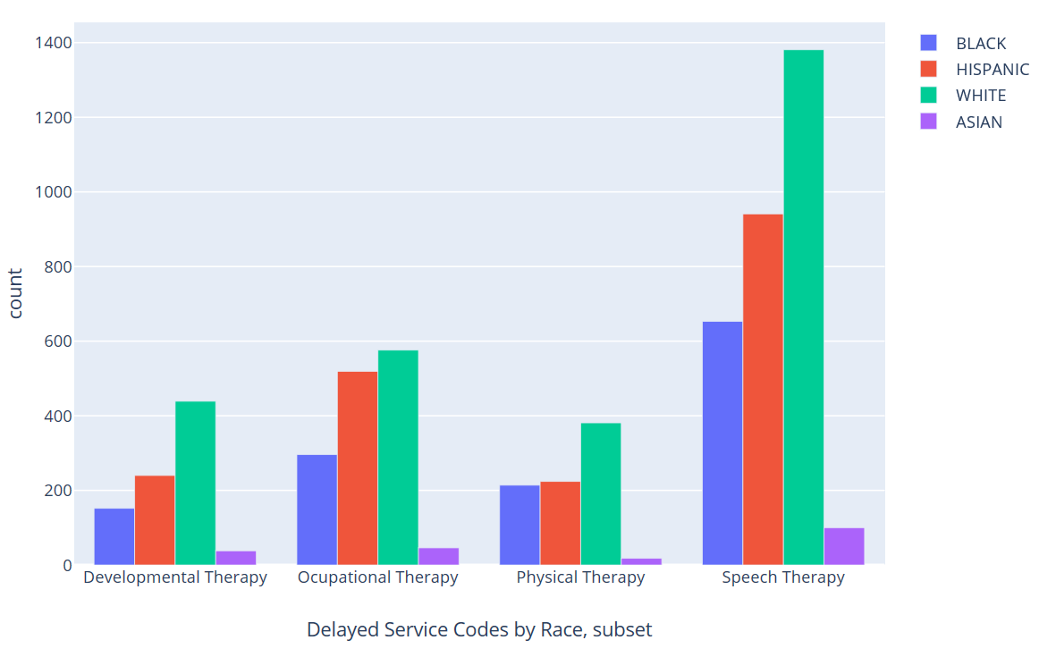

Figure 4.4: Number of Children that Experienced Delays for Different Reasons by Race

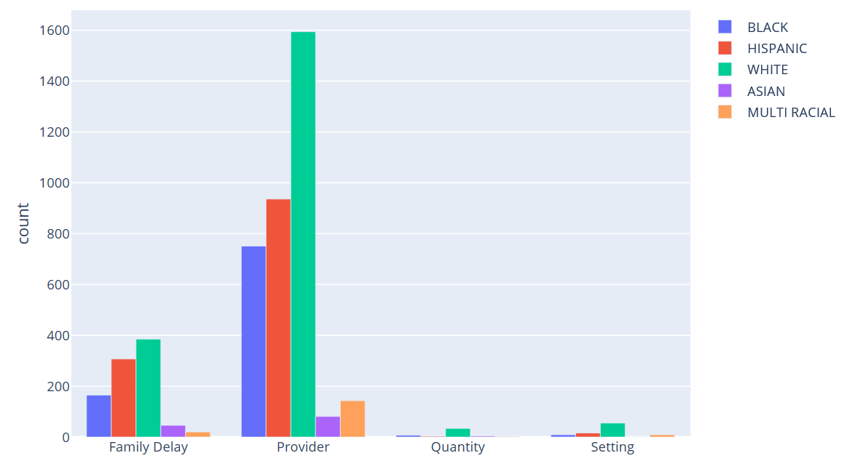

Table 4.3: Delay Reason by Race

Delay | Family Delay |  |  | Provider Delay |  |  | Quantity |  |  |  | Setting
ASIAN |  | 46 | 5% |  | 81 | 2% |  | 4 | 8% | 0 |  | 0%
BLACK |  | 165 | 18% |  | 751 | 21% |  | 7 | 14% | 9 |  | 10%
HISP. |  | 307 | 33% |  | 936 | 27% |  | 3 | 6% | 16 |  | 18%
MULTI |  | 20 | 2% |  | 143 | 4% |  | 2 | 4% | 9 |  | 10%
WHITE |  | 385 | 42% |  | 1594 | 45% |  | 34 | 68% | 55 |  | 62%
total |  | 923 | 100% |  | 3505 | 100% |  | 50 | 100% | 89 |  | 100%

Figure 4.1 shows the top four services that are delayed. The vast majority of delays are attributable to speech therapy, occupational developmental therapy, and physical therapy; however, speech therapy is also the largest service proscribed. Furthermore, it becomes clear that the bulk of delays stem from the inability to find a provider.

In visualizing the number of delays disaggregated by race and service code, a few things become apparent. First, Hispanic children are less likely than one would expect to experience physical therapy delays and more likely to experience occupational therapy delays. For the sake of completeness, Figure and Table 4.2 include data from all of the service codes. For the sake of viewing ease, Figure 4.3 limits its scope to the four most prevalent service codes.

An additional way to understand these discrepancies is to look at how reported delay reasons vary by race (Figure 4.4). A more detailed description of each of these delay types can be found in table 4.3. It is noteworthy that children of color appear to make up a larger proportion of “Family Delays” than “Provider” delays. An alternative way to state this is that white children account for a smaller proportion of family delays than they do provider delays. These differences are statistically significant; however, Table 4.3 expresses these differences numerically where it becomes clear that the differences are small (children of color make up 58.3% of family delays and 54.5% of provider delays). It is unclear why these differences exist, but they do represent deviations from expected values based on population counts.

Methodological Note: Figures 4.2, 4.3, and 4.4 count the number of services that were delayed, not the number of children that experienced delays. If a child experienced delays for both physical and speech therapy, both the Physical Therapy and Speech Therapy columns will increase by 1. All delays (meaning both resolved and unresolved delays) are included. Figure 4.1 counts the number of children, not the number of service codes.

Issue 5: Service delays vary across CFCs and type of service.

Figure 5.1: Prevalence of Service Code Delays across CFC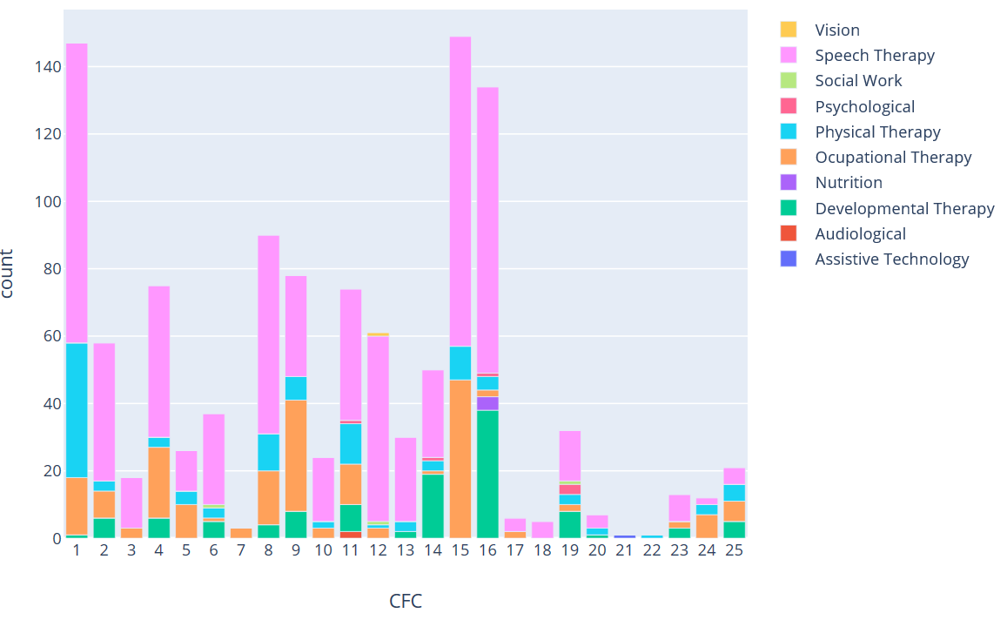

Table 5.1: Prevalence of Service Code Delays across CFC

Service Code | Audiolo-gical | Assistive Tech | Dev.  Therapy | Medical Eval | Nursing/  Health | Nutrition | Occ.  Therapy | Psych. | Physical Therapy | Service Coordi-nation | Social Work | Speech Therapy | Vision | Family Training/Support
CFC1 | 0 | 0 | 93 | 0 | 0 | 0 | 91 | 0 | 138 | 0 | 0 | 296 | 0 | 0
CFC2 | 0 | 0 | 78 | 0 | 0 | 1 | 87 | 4 | 23 | 0 | 0 | 129 | 0 | 1
CFC3 | 0 | 0 | 0 | 0 | 0 | 0 | 10 | 0 | 0 | 0 | 0 | 64 | 0 | 0
CFC4 | 1 | 0 | 111 | 0 | 0 | 3 | 157 | 15 | 59 | 1 | 0 | 310 | 0 | 0
CFC5 | 0 | 0 | 18 | 0 | 0 | 2 | 67 | 4 | 19 | 0 | 2 | 67 | 0 | 0
CFC6 | 2 | 0 | 32 | 1 | 0 | 0 | 22 | 2 | 36 | 0 | 9 | 119 | 1 | 0
CFC7 | 0 | 0 | 1 | 0 | 0 | 0 | 22 | 0 | 3 | 0 | 1 | 8 | 0 | 0
CFC8 | 2 | 0 | 55 | 0 | 0 | 5 | 131 | 1 | 101 | 0 | 8 | 308 | 1 | 0
CFC9 | 0 | 0 | 54 | 0 | 0 | 0 | 198 | 1 | 54 | 0 | 0 | 145 | 0 | 0
CFC10 | 0 | 0 | 3 | 0 | 0 | 0 | 35 | 0 | 53 | 0 | 0 | 94 | 0 | 0
CFC11 | 7 | 0 | 82 | 0 | 0 | 4 | 166 | 4 | 117 | 0 | 1 | 259 | 0 | 0
CFC12 | 1 | 0 | 13 | 0 | 0 | 4 | 35 | 2 | 27 | 0 | 2 | 232 | 6 | 0
CFC13 | 0 | 0 | 5 | 0 | 0 | 0 | 8 | 0 | 8 | 0 | 0 | 103 | 0 | 0
CFC14 | 0 | 0 | 109 | 0 | 0 | 0 | 14 | 8 | 16 | 0 | 0 | 158 | 0 | 0
CFC15 | 0 | 1 | 0 | 0 | 0 | 0 | 323 | 0 | 87 | 0 | 0 | 359 | 0 | 0
CFC16 | 0 | 0 | 166 | 0 | 0 | 18 | 24 | 3 | 52 | 0 | 0 | 270 | 0 | 0
CFC17 | 0 | 0 | 0 | 0 | 0 | 0 | 9 | 0 | 0 | 0 | 0 | 12 | 0 | 0
CFC18 | 0 | 0 | 1 | 0 | 0 | 0 | 1 | 4 | 0 | 0 | 0 | 31 | 0 | 0
CFC19 | 0 | 0 | 33 | 0 | 0 | 0 | 9 | 8 | 11 | 0 | 3 | 73 | 0 | 0
CFC20 | 0 | 0 | 9 | 0 | 0 | 0 | 6 | 3 | 10 | 0 | 4 | 51 | 0 | 0
CFC21 | 0 | 3 | 0 | 0 | 3 | 1 | 1 | 0 | 1 | 0 | 0 | 0 | 0 | 0
CFC22 | 0 | 0 | 4 | 0 | 0 | 0 | 2 | 0 | 5 | 0 | 0 | 4 | 0 | 0
CFC23 | 0 | 0 | 4 | 0 | 0 | 0 | 6 | 0 | 2 | 0 | 0 | 33 | 0 | 0
CFC24 | 0 | 0 | 5 | 0 | 0 | 0 | 40 | 1 | 11 | 0 | 0 | 10 | 0 | 0
CFC25 | 0 | 0 | 27 | 0 | 1 | 0 | 52 | 3 | 25 | 0 | 1 | 46 | 0 | 0
total | 13 | 4 | 903 | 1 | 4 | 38 | 1516 | 63 | 858 | 1 | 31 | 3181 | 8 | 1

Figure 5.1 graphs the number of delays attributable to all service codes for each CFC. Again, we see that the vast majority of delays are attributable to speech, physical, developmental, and occupational therapy. It is important to note that this data that specified service code is that of delayed cases – we do not know how many of each of these services were referred and not delayed. Consequently, we cannot make any conclusion as to the prevalence of referrals for a specific service code, only the prevalence of delays associated with a specific service. That said, if the number of delays is a rough proxy for the number of referrals, it could be surmised that certain service areas – namely mental health services – are under prescribed.

Issue 6: Children with lower incomes experience a greater likelihood of delays.

Because the data set was anonymized, income granularity was limited to the zip code level. This section does not examine individual income effects, but rather neighborhood level effects.

Figure 6.1: Zip Code Income by Delays
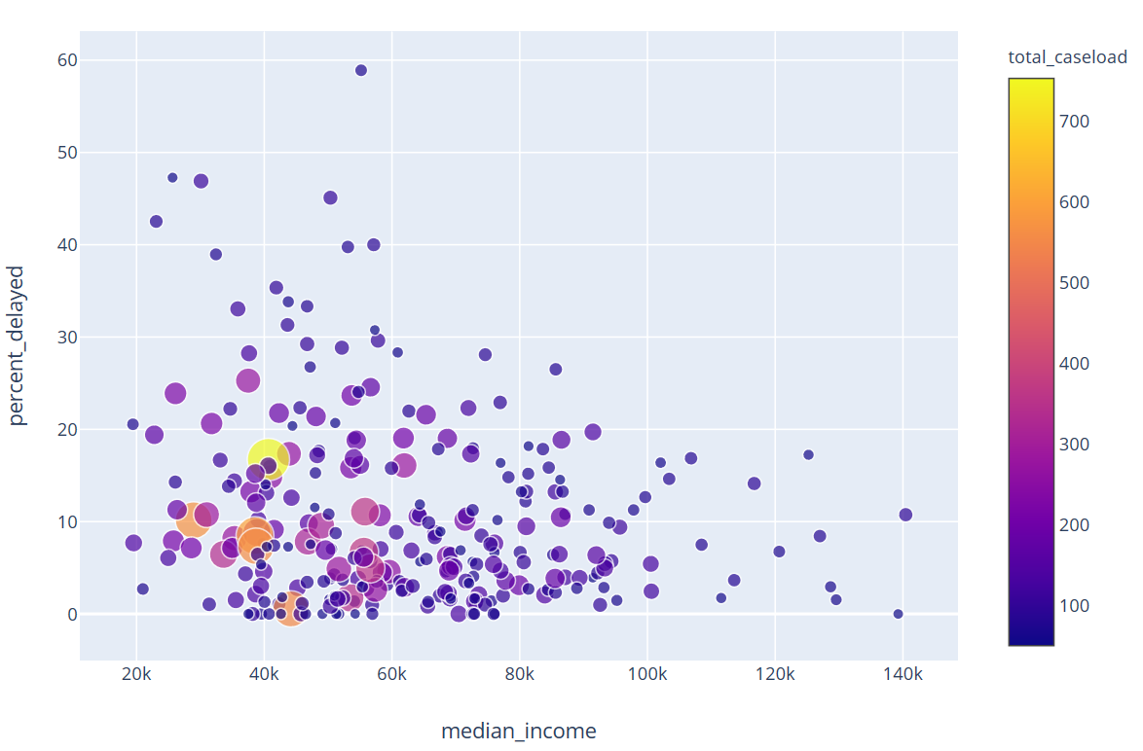

Figure 6.1 shows a modest, negative correlation between median income and the percent of cases that were delayed. The relationship between the likelihood of experiencing a delay and median income was examined using a probit model and was significant at the .001 level (β = -.000004, p < .0001). This model suggests that a $10,000 increase in income is associated with roughly a 4% decrease in the likelihood of experiencing a delay. Median Income is a still a statistically significant predictor at the .001 even after for controlling for the population density of a child’s zip code and for child’s race.

Methodological Note: The sample is limited to zip codes with a caseload of 50 cases or more in the figure, but not in that statistical analysis. The statistical analysis assumes that individual income is equal to the median zip code level income. The model is weighted by individual, not by zip code (meaning that high density regions are over represented compared to figure 6.1). Zip code level income data was gathered from the 2013 ACS survey. For technical reasons it was easiest to use 2013 ACS.

Recommendations:

To compare across groups, the y axis in figure 2.2 shifts from “count” to “percent” For viewing ease, Figure 2.2 only graphs the distribution of black and white children. To see all the distributions of black, white, Asian, and Hispanic children, click on the internet explorer symbol below the graph.
(X² (12, N = 4567) = 88.974, p <.001) across all delay X² (4, N = 4428) = 43.418, p <.001 if comparing only “Family Delays” and “Provider Delays”

